

**Veritas NetBackup**

**Plugin Configuration Guide**

Contents

Introduction 3

Supported Collection Types 3

Data Sources 3

NetBackup Configuration Checklist 4

Requirements 5

NetBackup Ports 5

Forward and Reverse Name Resolution 5

NetBackup Primary Server Access 5

PuTTY User Permissions 6

NetBackup RBAC Configuration (NetBackup 8.3 and newer) 7

Add Permissions for the *Bocada*Role 8

Example: MSSQL 8

API key (Optional) 8

Backup Data Collection 9

Backup Data Collection: REST API (Preferred) 9

Backup Data Collection: PuTTY/WinRM (Alternate) 10

Storage Data Collection 11

Storage Data Collection: REST API (Preferred) 11

Storage/Policy Data Collection: PuTTY/WinRM 12

Java and Commands: Support for Legacy Collection Methods 12

Troubleshooting 13

Reporting Notes 15

Parent without Children 15

Parent with Children 15

Children 15

Appendix A: Advanced Server Properties 16

Technical Support 18

# Introduction

This guide details how to configure Bocada data collection from NetBackup 8.1 and newer primary servers.

# Supported Collection Types

The plugin currently supports the following collection types from NetBackup servers:

|  |  |  |
| --- | --- | --- |
| **Collection Type** | **Supported** | **Description** |
| Backup | ✓ | Collects transactional details about backup, duplication and restore jobs. Example metrics include, start times, durations, bytes, files, errors etc. This includes In Progress jobs. |
| In Progress | ✓ | Collects basic information on backups that are running or have completed since the previous full Backup jobs data collection. These updates are included in the Backup updates, but are lightweight and can be scheduled more often than backup updates if needed. |
| Storage | ✓ | Collects point-in-time inventory information. Example metrics include, total recoverable gigabytes (storage), media volume count, media volume status, etc. |
| Policy | ✓ | Collects and stores information on policy attributes, schedules, storage units, storage groups, storage lifecycle policies and clients. |

# Data Sources

The plugin relies on the following NetBackup data sources:

* Activity Monitor
* Error Log
* Image List
* Policy/Schedule information (bppllist, bpplinfo, bpplinclude)
* Storage Unit List (bpstulist)
* Media List (medialist)
* Volume Pools (vmpool)
* Volume Query (vmquery)
* Volume Operation Commands (vmoprcmd)

# NetBackup Configuration Checklist

While detailed steps are included below, this is an overview of the steps to configure NetBackup collections on your Bocada Data Collection Server:

### All Methods:

* Verify required TCP ports have been opened
* Verify forward & reverse name resolution
* Add the Data Collection Server as an allowed server on the NBU Primary Server

### Preferred Collection Methods

#### Backup

* NetBackup 8.3 and newer: Configure RBAC Role you can use
  + with assigned user *or* [with API key](https://www.veritas.com/content/support/en_US/doc/135031700-135031704-0/v136359302-135031704)
* NetBackup 8.1.1 – 8.2: [Create a NetBackup REST API user](https://www.veritas.com/support/en_US/article.100042908)

#### Storage Collection (Rest API)

* Only supported for NetBackup 8.2 and higher: [Create a NetBackup REST API user](https://www.veritas.com/support/en_US/article.100042908)

#### Storage (without Rest API), Policy, and In Progress Collection

* Windows
  + Ensure WinRM is enabled on the NetBackup Primary Server
  + Create a user capable of accessing and running commands in *…\bin\admincmd and …/volmgr* on the NetBackup primary server
* Unix
  + Install PuTTY (plink) on the Bocada Data Collection Server
  + Create a user capable with the proper permissions

# Requirements

This section lists requirements that must be met prior to collecting data with the Bocada plugin for NetBackup.

## NetBackup Ports

When using NetBackup through a firewall, open the following ports for communication with the Bocada Data Collection Server(s):

|  |  |  |
| --- | --- | --- |
| **Daemon / Service** | **Default Port** | **Note** |
| *REST API* | 443 *or* 1556 | Backup and Storage collection for NBU version 8.3 and up |
| *REST API* | 1556 | Backup and Storage collection for NBU version 8.1.1 – 8.2 |
| *WinRM* | 5985 | Data Collection for Windows Primary Servers (Remote Desktop Protocol) |
| *PuTTY* | 22 | Data Collection for Unix Primary Servers (plink) |
| *Pbx* | 1556 | - |
| *Vmd* | 13701 | - |
| *Bpdbm* | 13721 | - |
| *Bpjobd* | 13723 | - |
| *Vnetd* | 13724 | - |
| *Bpcd* | 13782/TCP | - |

## Forward and Reverse Name Resolution

Forward and reverse name resolution must be available from the NetBackup Primary Server to the Bocada Data Collection server. If forward and reverse name resolution is not possible due to security restrictions, a host file must be edited. Modify the etc/hosts file on both the NetBackup Primary Server(s) and the Bocada Data Collection server to include each other. Example:

*192.16.x.x datacollector datacollector.domain.com*

## NetBackup Primary Server Access

The Bocada Data Collection server must be added as an additional server on the NetBackup Primary Server. This can be done with the following procedures:

1. Open the NetBackup Console.
2. Expand NetBackup Management
3. Expand Host Properties → Primary Servers.
4. Primary Server properties → Servers.
5. Add the Bocada Data Collector(s) in the Additional Servers box.

Note: Some users have found that adding the Bocada DCS as a media server as well as an additional server was necessary to grant permission to the DCS. Other users have found that adding as only a media server is sufficient for access.

1. Run bprdreq –rereadconfig (located in <NBU-Install-Path> NetBackup/bin/admincmd) to have NetBackup reread this file without cycling services.

## PuTTY User Permissions

A user with the following permissions are required:

1. Local access on the NetBackup Primary Server  
   1. On a Unix Master, the TTY requirement must be disabled globally, for the group, or the individual user set up for Bocada collection.  
      <https://www.shell-tips.com/linux/sudo-sorry-you-must-have-a-tty-to-run-sudo/>
   2. On a Unix Master, the user must have sudo configured with NOPASSWD set for the following commands:
      1. <install path>/netbackup/bin/admincmd/*
      2. <install path>/volmgr/bin/*

<https://www.shell-tips.com/linux/sudo-no-tty-present-and-no-askpass-program-specified/>

* 1. On a Windows Master, the user must have administrator rights to run the following commands:
     1. <install path>/netbackup/bin/admincmd/*
     2. <install path>/volmgr/bin/

1. Added to the <install path>/java/auth.conf on the NetBackup Primary Server with similar permissions:

<user> ADMIN=ALL JBP=ALL

# NetBackup RBAC Configuration (NetBackup 8.3 and newer)

Follow the steps below to configure an RBAC user/role for Bocada data collection if your NetBackup version is 8.3 or above.

1. Navigate to Security > RBAC:  
   Graphical user interface, application

   Description automatically generated
2. Add a *Custom* Role with a descriptive name:  
   Graphical user interface, text, application

   Description automatically generated  
   A picture containing logo

   Description automatically generated  
   Graphical user interface, text, application, chat or text message

   Description automatically generated
3. Assign Global Permissions: All available *View* for the following categories:
   * NetBackup management
   * Protection
   * Security (excluding certificate management)
   * Storage
4. Assigned a user to the new *Bocada Data Collection* role

## Add Permissions for the *Bocada*Role

Add permissions for the Bocada Data Collection role for all relevant workloads for View and Discover

# Example: MSSQL

## API key (Optional)

Bocada can collect data with a username and password of the user assigned to the *Bocada Data Collection* role. If using an API key is preferred, then only one step remains.

Create an API key for the user assigned the *Bocada Data Collection* Role. Set the key so it does not expire for a long enough period to prevent collection failures in Bocada.

# Backup Data Collection

## Backup Data Collection: REST API (Preferred)

The Rest API method should be selected for NetBackup version 8.1.1 and higher. NetBackup 8.3 introduced RBAC which allows for utilization of an API Key instead of a username and password and enables collection over port 443 (HTTPS) in addition to 1556.

### Backup Data Source

Set the data source for Backup to REST API

### Domain Type

* NT
* LDAP
* Unixpwd
* vx

### Domain Name

* Set the domain name of the REST API user. This is not required when using an API Key with NetBackup 8.3 and newer.

### Username

* This is not required when using an API Key with NetBackup 8.3 and newer, see below
* NetBackup 8.1.1 – 8.2: Enter the [NetBackup REST API user](https://www.veritas.com/support/en_US/article.100042908)
* NetBackup 8.3 and newer: Enter the user assigned to the RBAC Role

### Password

* This is not required when using an API Key with NetBackup 8.3 and newer
* Enter the appropriate password for the user above

### API Key

* This is not required when providing a username/password.
* Enter the [API Key generated for the RBAC role](https://www.veritas.com/content/support/en_US/doc/135031700-135031704-0/v136359302-135031704) configured above if you are using API Key.

### Port

Default is port 1556 but can be set to 443 for NetBackup 8.3 and newer.

## Backup Data Collection: PuTTY/WinRM (Alternate)

The PuTTY/WinRM method should only be used for Backup data collection when the NetBackup version is older than 8.1.1. For newer versions of NetBackup, please reference the API method above.

### Backup Data Source

Set the data source for Backup to PuTTy\WinRM. If the

### PuTTY/WinRM commands path

This is the path on the NetBackup Primary Server where the admin commands are located. For example, the default location on windows is: *C:\Program Files\VERITAS\NetBackup\bin\admincmd*

### PuTTY/WinRM Port

Default is port 5985.

### PuTTY/WinRm commands user name & password

The username and password specified should have permission described in PuTTY User Permissions.

### PuTTY/WinRm commands private key file

As an alternative to using a password with the user name, a private key can be used to access the NetBackup Primary Server to collect data.

# Storage Data Collection

## Storage Data Collection: REST API (Preferred)

Storage Data Collection Rest API uses the same settings as Backup Data Collection Rest API.

The Rest API method should be selected for NetBackup version 8.2 and higher. NetBackup 8.3 introduced RBAC which allows for utilization of an API Key instead of a username and password and enables collection over port 443 (HTTPS) in addition to 1556.

Important Limitation: The NetBackup REST API does not provide any details on tape storage, specifically volumes, volume pools or volume groups. If the data collected for report is insufficient, consider changing the collection method to PuTTY WinRM.

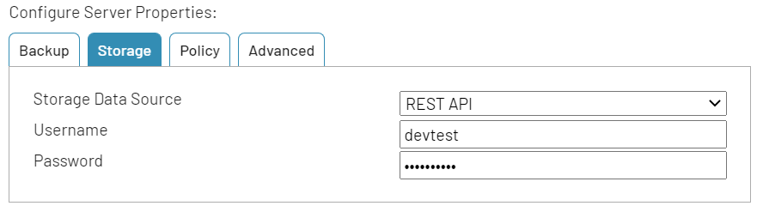

### Storage Data Source

Set the data source for Storage to REST API

### Username

* It shows the same username entered for Backup data collection Rest API.
* Storage collection will use the same settings added for Backup data collection Rest API.

### Password

* It shows the encrypted password entered for Backup data collection Rest API.
* Storage collection will use the same settings added for Backup data collection Rest API.

## Storage/Policy Data Collection: PuTTY/WinRM

The PuTTY/WinRM method should be set for Storage and Policy data collection for NetBackup version 8.1 and newer.

### Storage/Policy Data Source

Set the data source for Backup to PuTTy\WinRM. If the

### PuTTY/WinRM commands path

This is the path on the NetBackup Primary Server where the admin commands are located. For example, the default location on windows is: *C:\Program Files\VERITAS\NetBackup\bin\admincmd*

### PuTTY/WinRM Port

Default is port 5985.

### PuTTY/WinRm commands user name & password

The username and password specified should have permission described in PuTTY User Permissions.

### PuTTY/WinRm commands private key file

As an alternative to using a password with the user name, a private key can be used to access the NetBackup Primary Server to collect data.

# Java and Commands: Support for Legacy Collection Methods

If you are running older versions of NetBackup and/or Bocada, please contact Bocada Support for assistance. There is also a separate Plugin guide that described additional legacy data collection configurations.

# Troubleshooting

### Issue: Data Collection Failure with Access or failbit set error

This section will suggest troubleshooting steps if your data collection fails with either of the following messages:

* Error 537: Unable to access NetBackup BPDM service or access denied.
* Error 545:ios_base::failbit set

Please review the requirements for collection at the beginning of this guide. These errors can be caused by missing data collection prerequisites:

* Verify that the Bocada Data Collection server is named as an allowed server on the NetBackup server.
* Be sure that the NBU services are restarted after Bocada DCS added as an allowed server. Note that the command in NBU that is supposed to reread the configuration file bp.conf is *not* sufficient for Bocada to connect.
* Be sure that the DNS name lookup is consistent going both directions. The NBU server needs to be able to reverse nslookup by IP address the Bocada DCS and see the same name as was added to NBU as an allowed server. Check to see what the forward and reverse lookup is from the NBU server.
  + C:\>nslookup <NetBackup_server_name>
    - must show the correct IP address of the Bocada DCS. This is a forward DNS lookup.
  + C:\>nslookup <IP_addresss>
    - is the reverse lookup and must produce the identical matching Bocada DCS server name as the forward lookup.
* Note that you can test some of the connectivity and permissions by trying telnet to the relevant port from a cmd window prompt.
  + C:\>telnet <NetBackup_server_name> 13721

### Issue: Backup Data Collection timeout or is slow or takes longer time than expected

Starting after Bocada 19.9.6, NetBackup plugin collects client information such as OS name and version. This data gets displayed on Backup Clients report under Client platform and Client version columns and is valuable when monitoring the clients through Bocada. In some cases, the data collection process for getting this client info may take longer than expected due to number of clients and network load. If the collection fails due to timeout error, there is an option to disable the collection process for client info by going to Server Properties and setting “Collect NBU client info” on *No*. Default value is *Yes*.

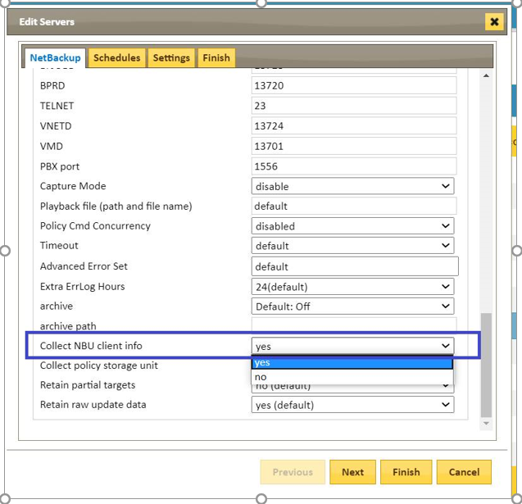

### Issue: Data collection failing after Bocada upgrade to 21.3.9 or later version

On previous Bocada versions prior to 21.3.9, “PuTTY/WinRM” behaves differently . Whenever command method for bpgetconfig failed, backup collection continued working. It missed some non-critical data, but all required data (about 90%) was mined successfully via NetBackup internal services. The collection used to succeed missing not critical data like Client info (Netbackup client version, Netbackup client OS version etc.).

To get collections working again, switch data collection data source from “PuTTY/WinRM” to “Commands” and restart Data Collection Service. Even if you do not install PuTTY or configure WinRM, using the PuTTY/WinRM method will skip the error and continue with backup job collections.

To further speed up collections, you should also disable In Progress Job collection, unless you know that you absolutely using IPJ data. In *Edit Server*, *Settings* tab set *Run In Progress Jobs after Backup Collection* to ***Do not run In Progress Jobs*** .

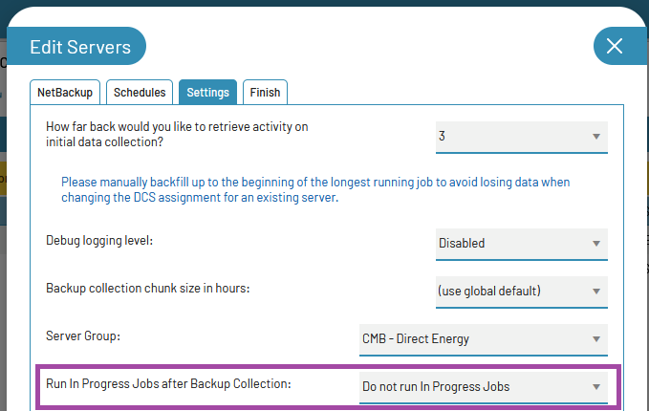

# Reporting Notes

### Parent/Child Job Roll-up

Certain jobs in NetBackup are ‘Parent’ or ‘Child’ jobs. These jobs are collected as usual by Bocada, but may appear differently in the Bocada database or in reports:

## Parent without Children

bytecount = -1 in DB, ‘unavailable’ in reports

errorcount = actual errorcount

errorset = actual errorset

description = NetBackup parent Job ID

groupsessionname = description

## Parent with Children

bytecount = -2 in DB, ‘unavailable’ in reports

errorcount = sum of children error count

errorset = accumulation of children’s error sets – i.e. if children have error sets of 9,2,8,8,2,5 and 9, then parent will have 2,5,8 and 9)

description = NetBackup parent Job ID

groupsessionname = description

## Children

bytecount = actual bytecount

status = actual status

errorcount = actual errorcount

errorset = actual errorset

description = NetBackup child Job ID

groupsessionname = Parent Job ID

You will also see that the jobdatetime for parent is earlier than all the children (starts first) and the duration for the parent is approximately the sum of all the children (finishes after all children finish)

# Appendix A: Advanced Server Properties

Advanced Server Properties should be left at default values unless required. If there are any questions regarding the use of these properties, please contact Bocada Support.

### Username & Password

These credentials serve two purposes:

1. When using the Java Admin Console methods to data collection, this is the user entered when first launching the Admin Console from the DCS to cache the signed certificate.
2. When Media Access Protocol is set to BpRsh, MsTelnet or SSH (not Local), this same user will be used to connect to the NetBackup server.

### Media Data Temp Path

When using ‘MsTelnet’ Media Access Protocol to access Storage data on Windows servers (default is ‘c:\\tmp’).

### NetBackup Install Path

Default directory for a standard installation is *C:\Program Files\VERITAS*. If using a non-default location, enter the path where NetBackup has been installed.

### NetBackup Remote Admin Console (Legacy Method)

For Policy and Storage collection (using Local protocol), enter the path where the NetBackup Remote Admin Console was installed on the Bocada Data Collection server. The standard installation directory is *C:\Program Files\VERITAS\NetBackup\bin\admincmd* and this value is populated by default.

### NetBackup Java Admin Install Path

If NetBackup collections are using the Java method then the Java Admin Console, which must be installed on the Bocada Data Collection server, and its path correctly called out in the Server Properties. However, even for earlier versions, this console should be installed for proper mapping of virtual environment (VMware policy type) backups to Bocada Virtual Reports. The default location is *C:\Program Files\VERITAS\Java*, but multiple versions of Java Admin Consoles can be installed simultaneously, and this location may have been changed; be certain to specify the path to the version of the console which matches the version of the NBU server.

### Time Zone

Select the time zone where NetBackup server resides. This setting ensures times are displayed consistently in environments that span multiple time zones. Data extracted from the NetBackup server is converted to Coordinated Universal Time (UTC), then converted to the time zone chosen in the report criteria.

### Custom Query Set

Used for Extensible Data Mining or custom update functionality. Please contact Bocada Support for more information.

### Sybase ODBC Driver (Legacy Method)

Registry information for the ODBC Driver installed with the NBU Client. NOTE: Please verify that this value is correct, as the default filled in by the plugin was incorrect in previous product versions.

### Database host name (Legacy Method)

Host name required for connection to the NBDB database. Default value is the NBU Master Server name, so this value must be entered if the server name is entered as IP address or fully-qualified name.

More information can be found in the NetBackup Database section of this document.

### Database server (Legacy Method)

The database Instance name required for connection to the NBDB database. Default value is the NBU Master server prefaced by “NB_”, so this value must be entered if the server name is entered as IP address or fully-qualified name. More information can be found in the NetBackup Database section of this document.

### Database name (Legacy Method)

Database name required for connection to the NBDB database. Default value is “nbdb”; more information can be found in the NetBackup Database section of this document.

### Database user (Legacy Method)

User name required for connection to the NBDB database. Default value is “dba”; more information can be found in the NetBackup Database section of this document.

### Database user password (Legacy Method)

Password for the database user required for connection to the NBDB database. Default value for versions 7.6 and older of NetBackup is “nbusql”; more information can be found in the NetBackup Database Password section of this document.

### Media Access Protocol (Legacy Method)

For Storage collection, select the service protocol to be used by the plugin.

* BpRsh or SSH (Unix)
* MsTelnet (Windows)
* Local (Remote Admin Console for Unix or Windows)

### NetBackup Version

Used to specify NBU versions before 7.1; For all later versions, this should remain as the default value ‘Auto Detect’.

### Port Properties (BPCD, BPDBM, etc.)

These are the default values for the ports expected, and should not be changed from default values unless specified.

### Capture Mode

Used for debugging purposes, this setting should remain at ‘Disabled’ unless directed by Bocada Support.

# Technical Support

For technical support or a copy of our standard support agreement, please contact us.

**E-mail:** [support@bocada.com](mailto:support@bocada.com)

**Support Portal:** <http://www.bocada.com/support/>

**Phone:** +1-425-898-2400